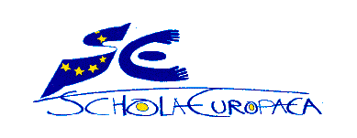

Varese, 23-06-2020
Dear Parents/Guardians,
The book list for the academic year 2020-2021 can be found on the school website under the “Secondary cycle” menu. Choose “Pedagogy” then “textbooks 2020-2021”to access the book list for each individual class.

Please remember to not only check your child’s class and section, but also the items such as 1X, 2X, 3X etc. for lessons taught in Language 2, 3, or 4, and SWALS.

Kind regards,

La Scuola

Column A
DE: German language section
EN: English language section/Anglophone section
FR: French language section/Francophone section
IT: Italian language section
NL: Dutch language section
X: Classes taught in L2/L3/L4 e.g. Options + ONL + SWALS: Students without a language section

